Experiment No. 6

**BASE PYTHON FOR SCIENTIFIC COMPUTING**

Programming Assignment Screenshots

Abellera, Joshua Beaver Q.

2ECE-D

**Problem 1:**

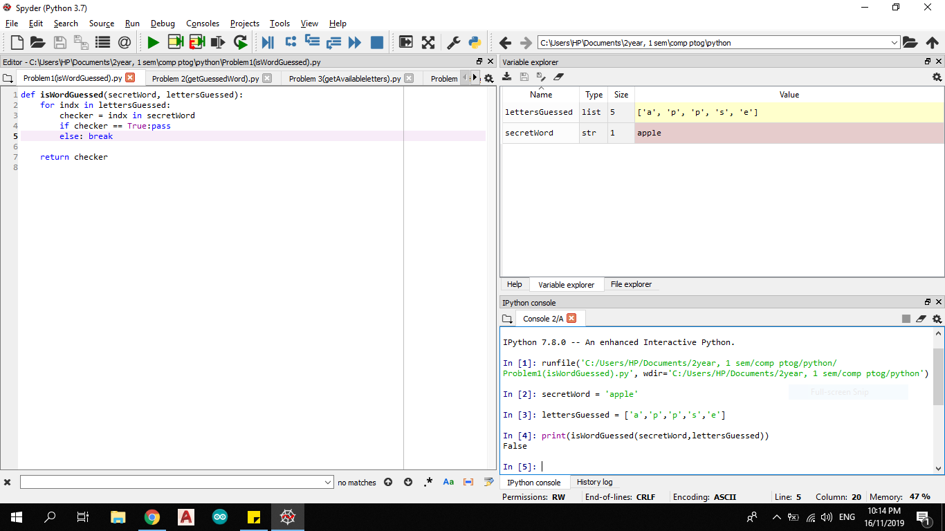

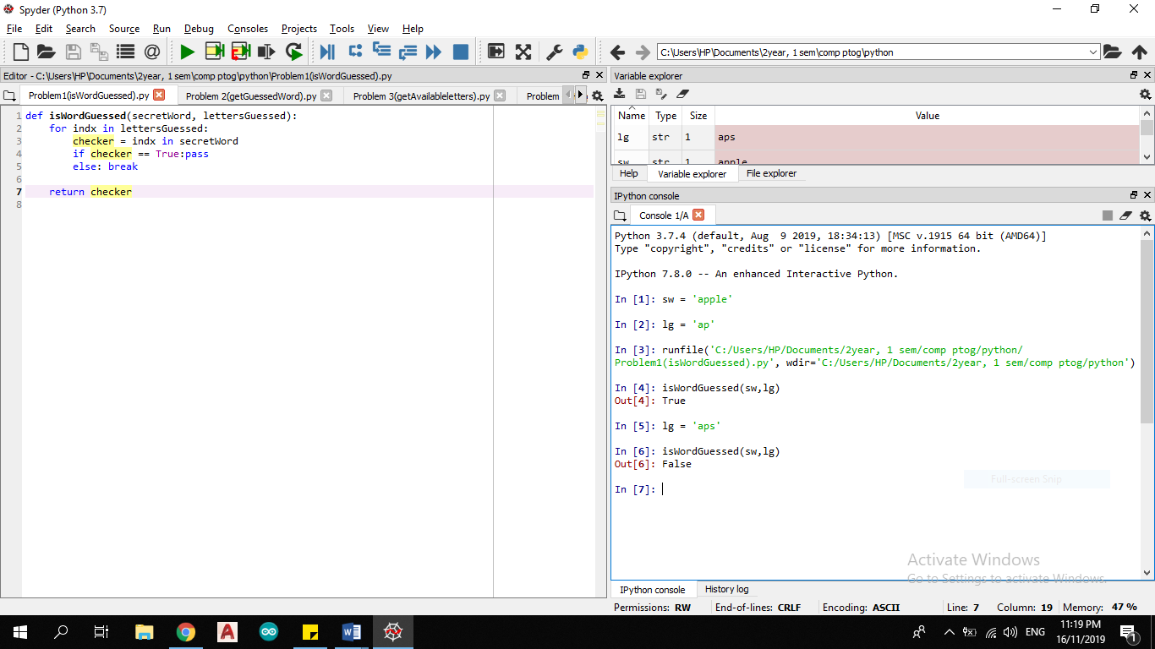

**Problem 2:**

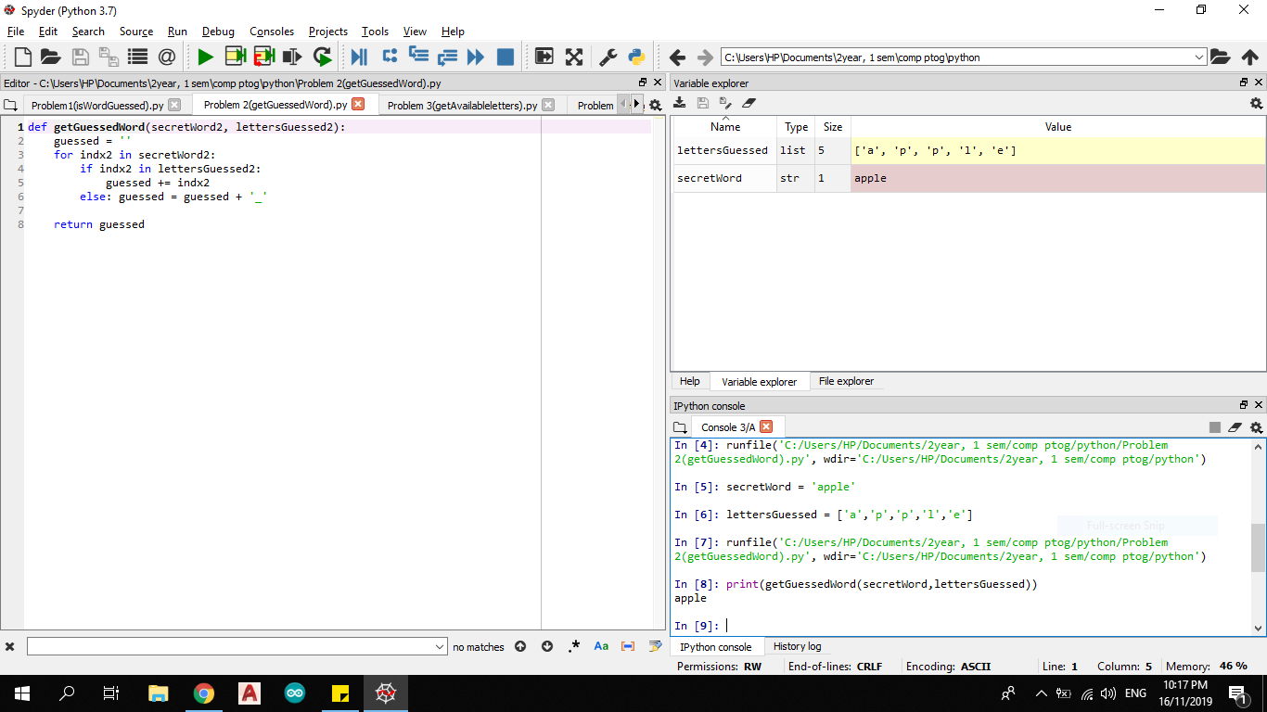

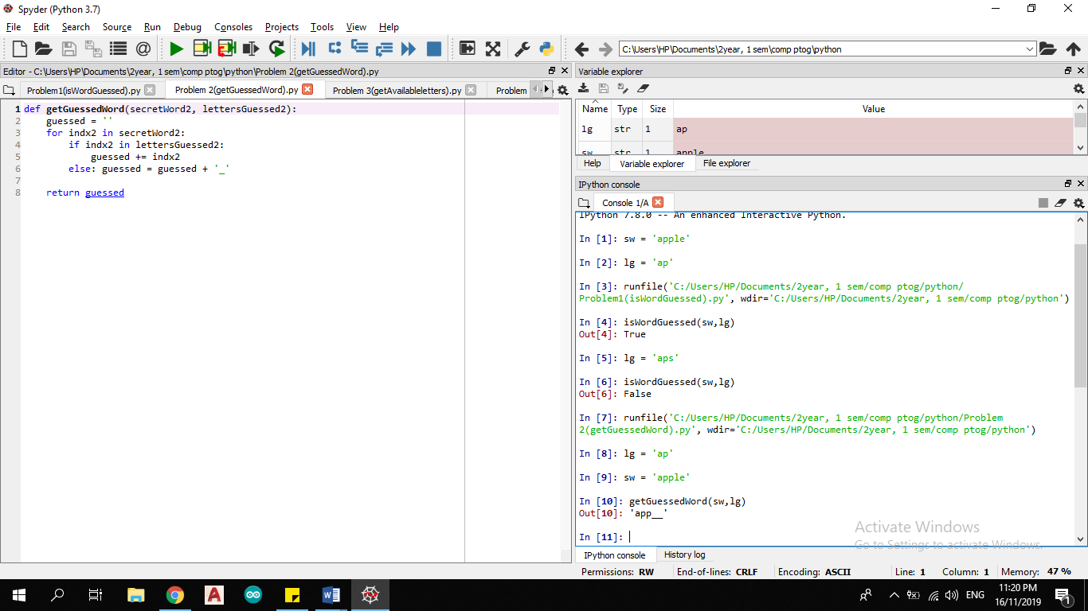

**Problem 3:**

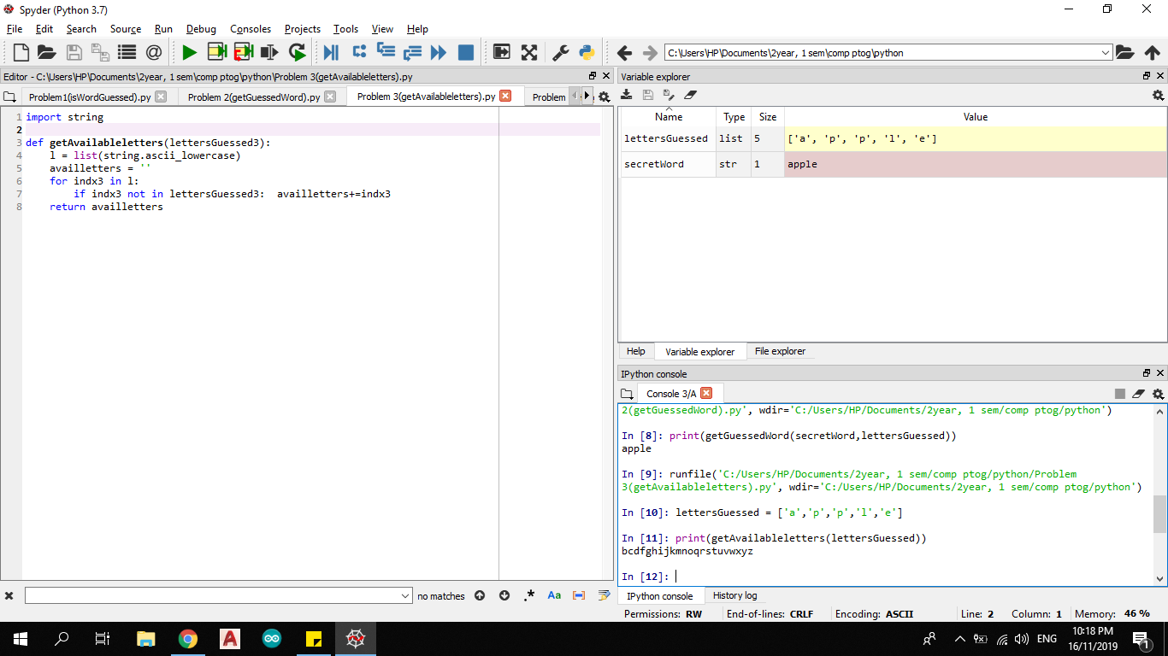

**Problem 4:**

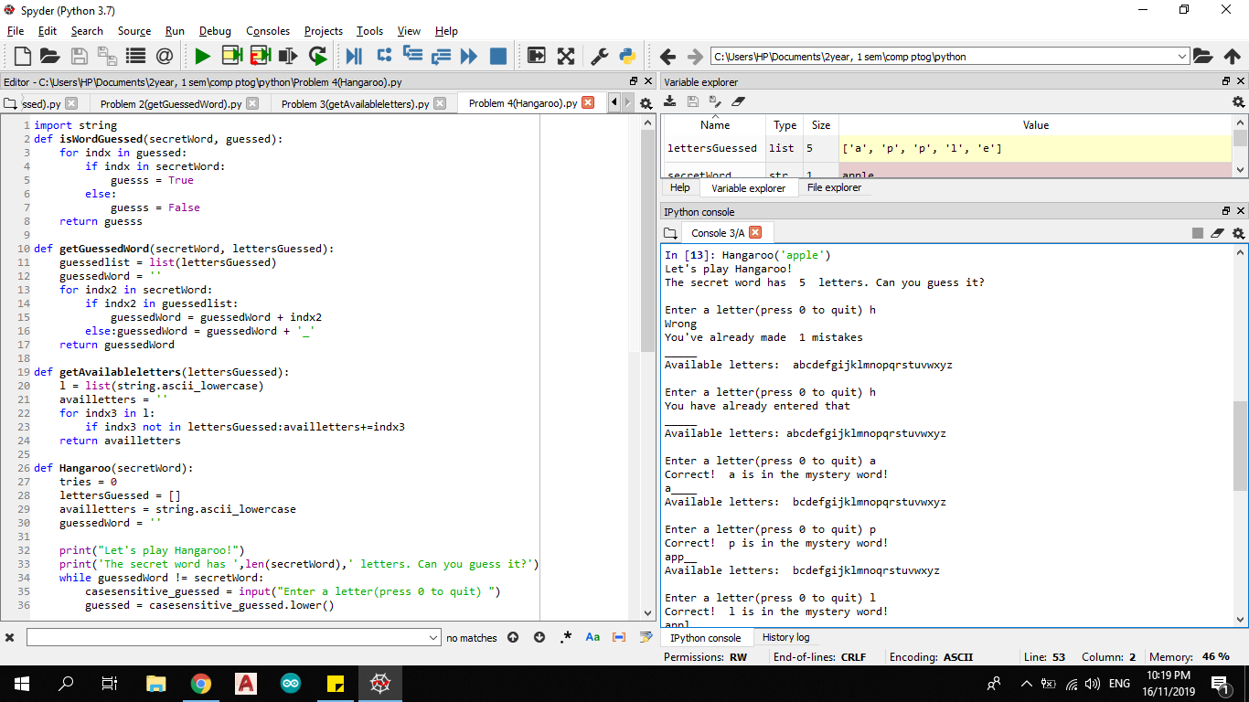



* Quitting the game:

